EUR/USD Exchange Rate Forecasting Using Deep Neural Networks:
A Comparative Analysis of LSTM, GRU, and CNN-LSTM Architectures
Module: Time Series Analysis | Dataset: Dukascopy EUR/USD M30 (Jan 2024 – Apr 2026)

1. Introduction
Forecasting foreign exchange rates is one of the more challenging problems in quantitative finance. Currency markets operate continuously across global sessions, driven by macroeconomic announcements, central bank policy shifts, geopolitical developments, and the collective behaviour of millions of market participants. This complexity makes traditional linear time series models inadequate for capturing the non-stationary, non-linear dynamics inherent in intraday price movements.
This study applies three deep learning architectures — Long Short-Term Memory (LSTM), Gated Recurrent Unit (GRU), and a hybrid Convolutional Neural Network combined with LSTM (CNN-LSTM) — to forecast the next 30-minute closing price of the EUR/USD currency pair. The dataset was sourced from Dukascopy and covers the period from January 2024 to April 2026, comprising over 22,000 M30 bars. The primary objective is to evaluate each architecture's predictive accuracy using a standardised set of error metrics and to assess their suitability for short-term intraday forecasting.

2. Dataset and Exploratory Analysis
The EUR/USD M30 bid OHLCV dataset was obtained directly from the Dukascopy Swiss banking platform. Each record includes open, high, low, close prices, and transaction volume for every 30-minute interval across the study period. After converting Unix millisecond timestamps to UTC datetime indices and dropping incomplete rows, the cleaned dataset spanned January 2024 through late April 2026, yielding approximately 22,400 usable observations — well within the 50,000-row ceiling specified for this assignment.
Figure 1 presents a three-panel overview of the raw data: the EUR/USD closing price series, transaction volume, and the distribution of 30-minute log returns. The price chart reveals a notable depreciation from roughly 1.10 in mid-2024 down to a local trough near 1.025 in late 2024, followed by a sustained recovery that pushed prices above 1.18 by early 2026. This structural shift means the dataset contains both a bearish and a bullish regime, making it a meaningful test for model generalisation. The return distribution shows the characteristic leptokurtic shape typical of high-frequency financial data — a sharp central peak with heavier-than-normal tails — reflecting the mixture of quiet consolidation periods and sudden volatility spikes.
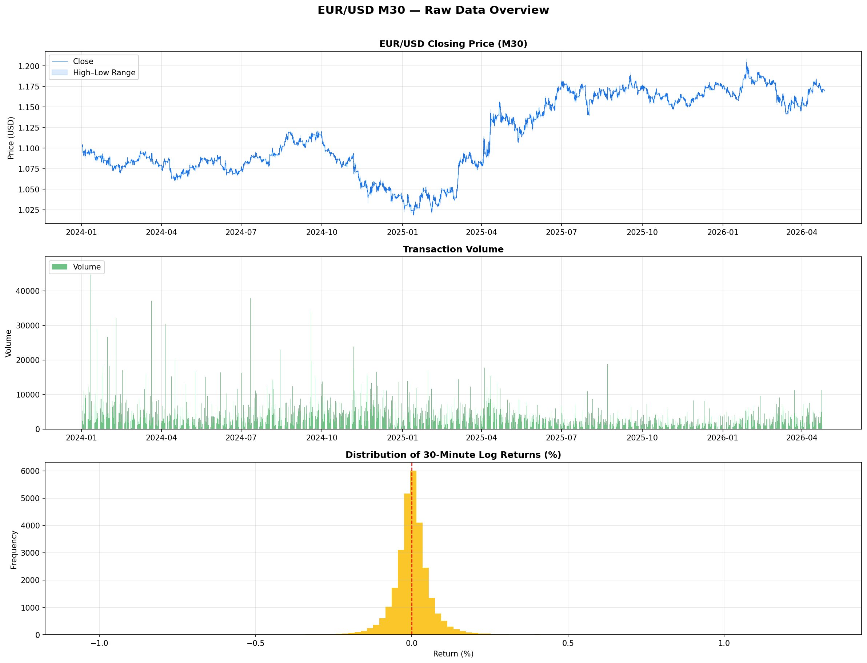
Figure 1: EUR/USD M30 raw data overview — closing price series, transaction volume, and 30-minute log return distribution (Jan 2024 – Apr 2026).
Figure 2 aggregates the data into monthly average closing prices. The bars confirm the secular downtrend through most of 2024, the low point in December 2024 to January 2025, and the recovery extending into 2026. This macro context informed the decision to use a chronological 70/15/15 train-validation-test split rather than random shuffling, which would introduce look-ahead bias.
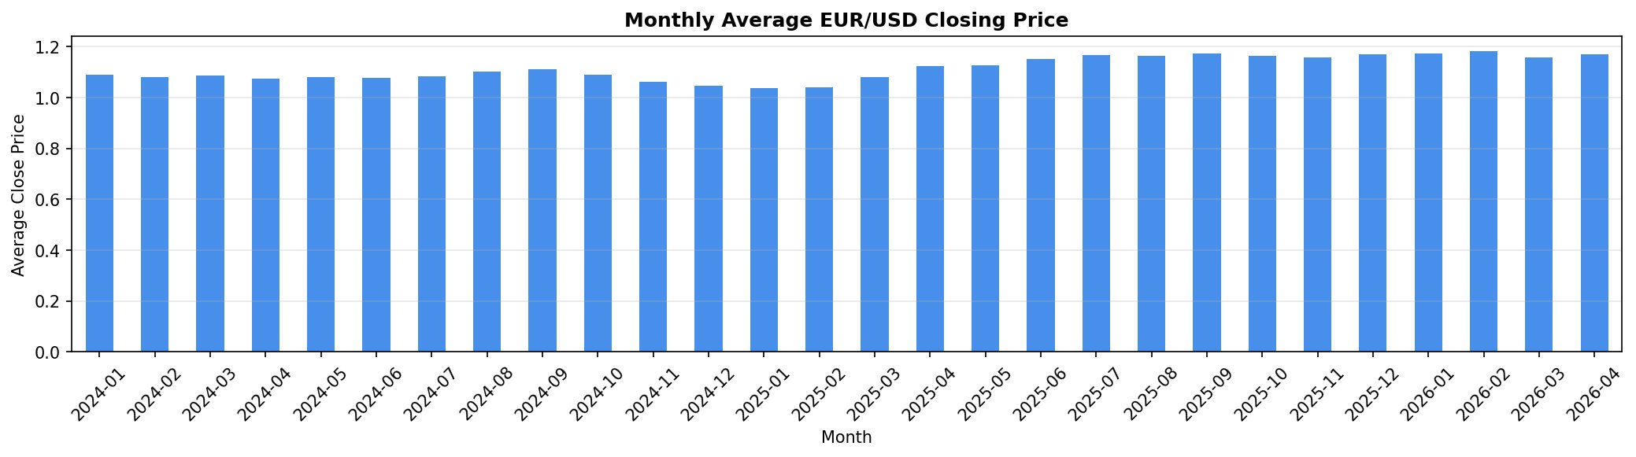
Figure 2: Monthly average EUR/USD closing price across the full dataset period, illustrating the 2024 depreciation cycle and subsequent 2025–2026 recovery.

3. Feature Engineering
Raw OHLCV data alone provides limited discriminative signal for a neural network. A comprehensive feature set of 31 variables was constructed, spanning trend, momentum, volatility, and volume dimensions alongside binary candlestick pattern flags and temporal markers.
Trend indicators included Simple Moving Averages at 10 and 20 periods (SMA-10, SMA-20), their exponential counterparts (EMA-10, EMA-20), and the full MACD triplet — the MACD line, signal line, and histogram. Momentum was captured by RSI-14 and the Stochastic Oscillator (%K and %D lines). Volatility features comprised all five Bollinger Band outputs (upper, lower, middle, bandwidth, and %B position) alongside the Average True Range. On-Balance Volume served as the sole volume-derived indicator. Price-derived features included the candle high-low range, open-close delta, one-period log return, and 5-bar and 10-bar percentage returns. Four binary candlestick pattern flags — Doji, Bullish Engulfing, Bearish Engulfing, and Hammer — were added to capture discrete pattern-based information. Finally, hour-of-day and day-of-week integers provided a proxy for session-driven seasonality.
The correlation heatmap in Figure 3 reveals the expected high collinearity among price-level features (OHLC, SMAs, EMAs, Bollinger Bands). The momentum and oscillator group shows moderate internal correlation, while the binary candlestick flags and temporal features remain largely orthogonal to the rest of the feature space — confirming their value as complementary signals.
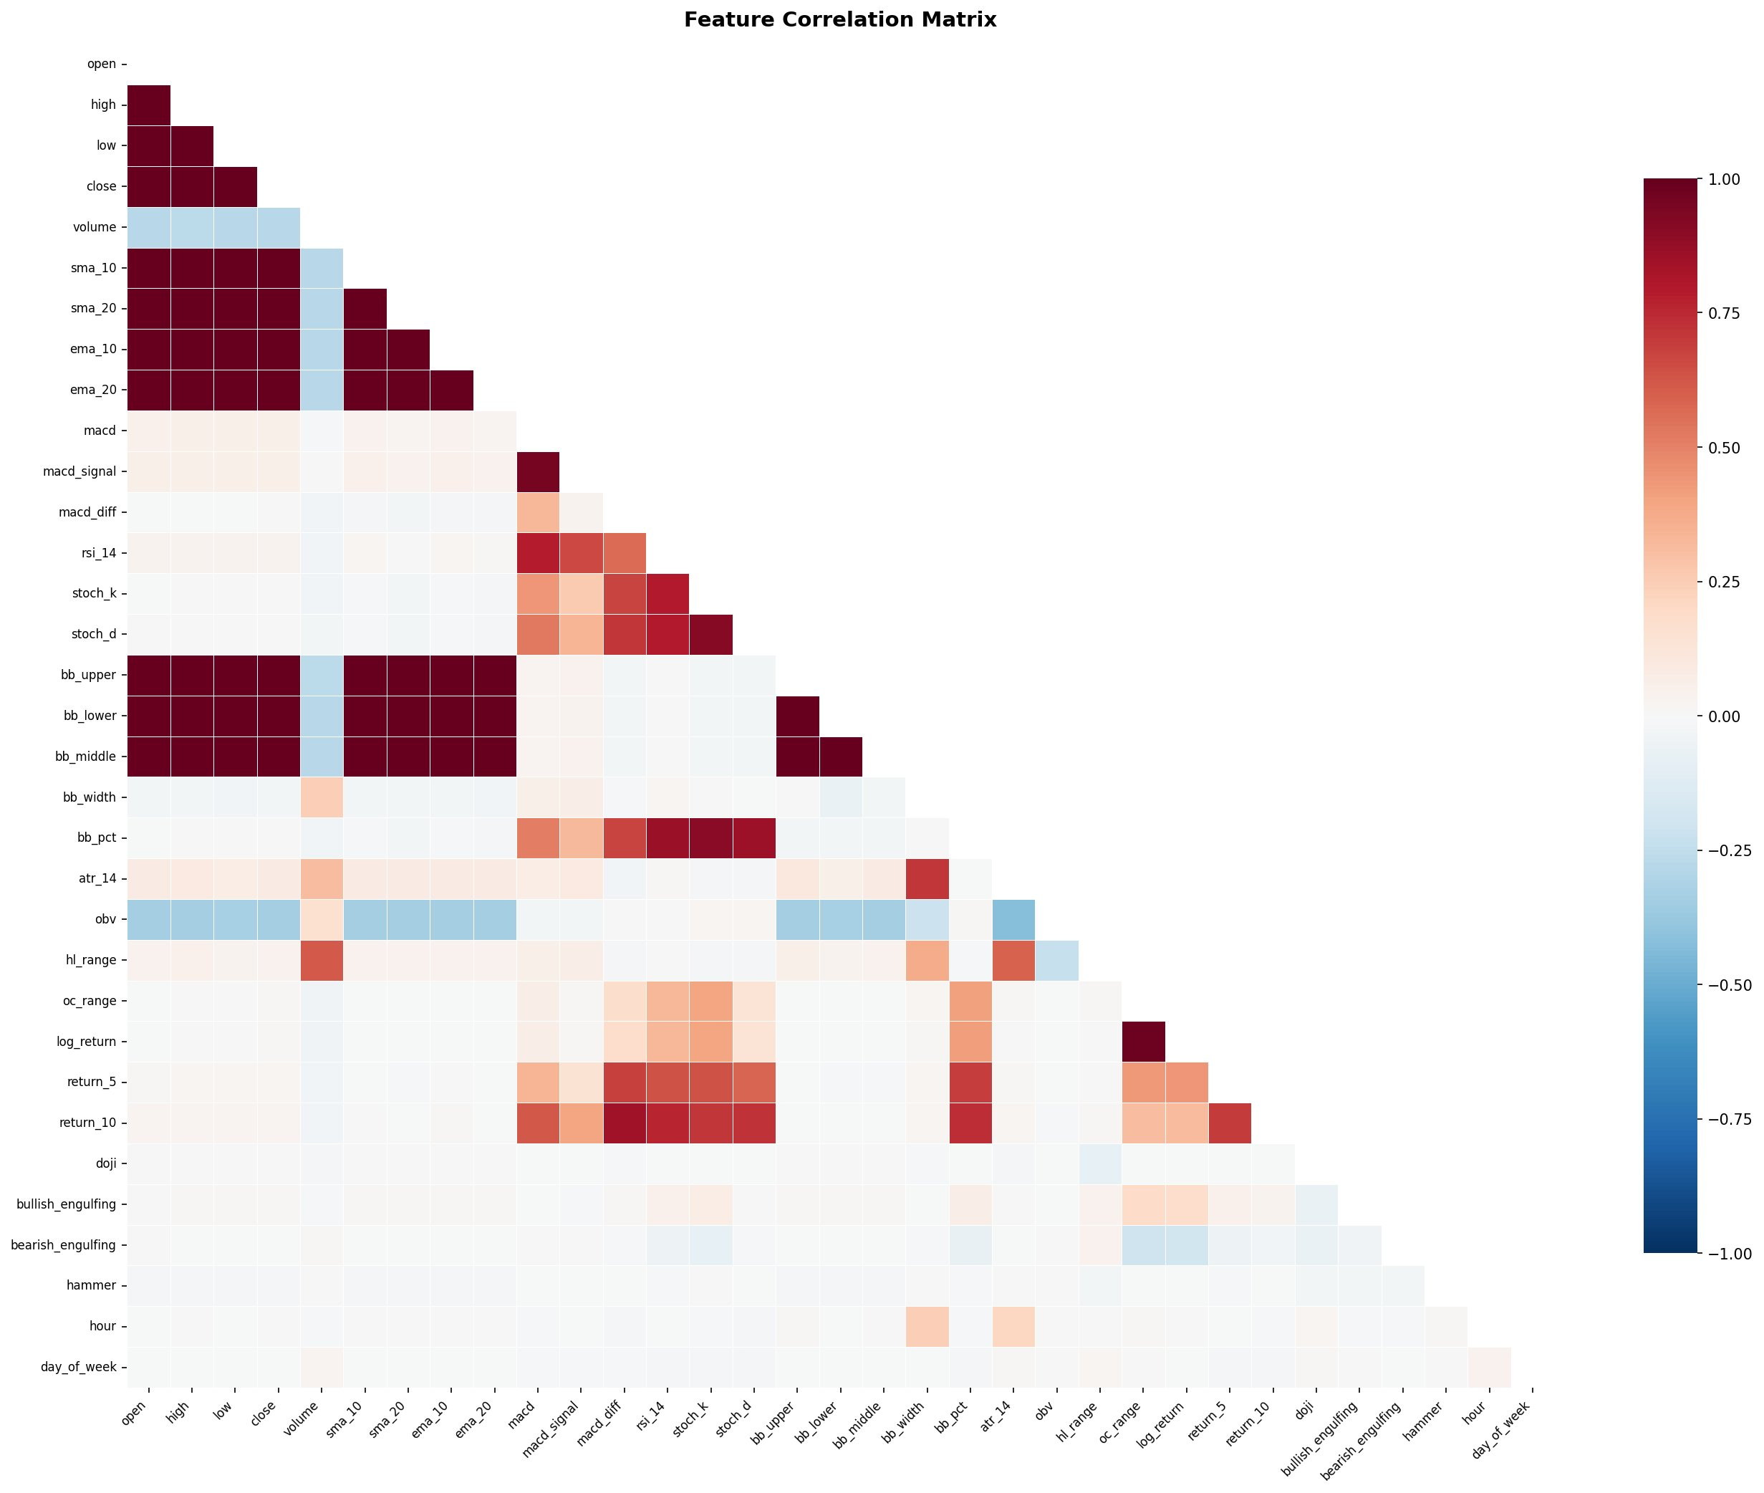
Figure 3: Lower-triangle Pearson correlation heatmap across all 31 engineered features. Dark red indicates strong positive correlation; dark blue indicates strong negative correlation.
Figure 4 illustrates how four key indicator groups behaved over the most recent 500 bars. Bollinger Band squeezes preceding directional breakouts, RSI excursions above 70 and below 30, MACD histogram polarity changes, and ATR spikes are all visible — providing qualitative confirmation that the feature set carries genuine predictive content.
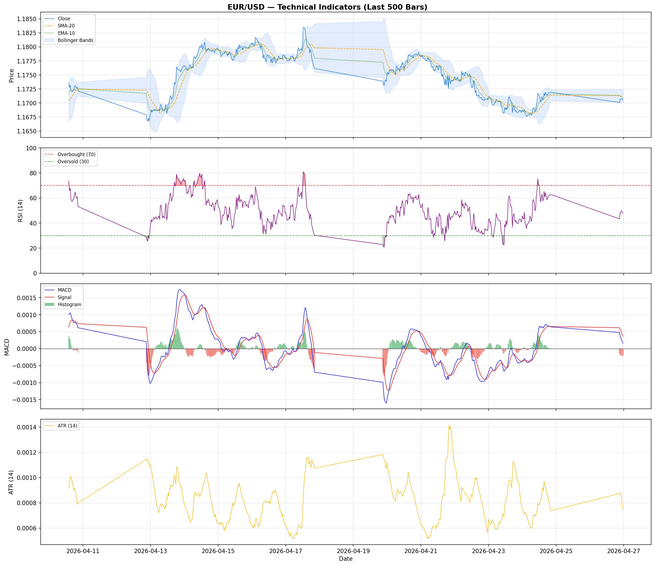
Figure 4: Technical indicator overlay on the last 500 M30 bars — closing price with Bollinger Bands and moving averages (top), RSI-14 (second), MACD (third), and ATR-14 (bottom).

4. Methodology

4.1 Data Preparation
Features were normalised to the [0, 1] range using MinMaxScaler fitted exclusively on the training set; validation and test sets were transformed using the training scaler parameters only, preventing any information leakage. A sliding window of 48 time steps (equivalent to 24 hours of look-back) was used to construct input sequences. Each input tensor X[i] corresponds to a (48 × 31) matrix of normalised feature values, with target y[i] set to the normalised closing price of the immediately following bar. The final dataset was split chronologically: 70% training (~15,680 rows), 15% validation (~3,360 rows), and 15% test (~3,360 rows).

4.2 Neural Network Architectures
Three distinct architectures were implemented and compared:
LSTM Model: Two stacked LSTM layers (64 units followed by 32 units), each with L2 regularisation (λ = 1×10⁻⁴) and dropout, feeding into a dense layer with batch normalisation before the single-unit regression output. LSTMs are well-suited to long-range sequential dependencies through their gating mechanism, which explicitly controls information retention across time steps.
GRU Model: Structurally identical to the LSTM but replacing the LSTM cells with GRU cells. GRUs merge the forget and input gates into a single update gate, reducing the parameter count while often achieving comparable or faster convergence. This architectural parity allows for a controlled comparison of the two cell types under identical training conditions.
CNN-LSTM Model: A hybrid architecture that prepends two Conv1D layers (64 and 32 filters, kernel size 3, same padding) and a MaxPooling1D layer to the LSTM stack. The convolutional block acts as a local pattern extractor — identifying short-range features such as momentum bursts or candlestick clusters — before the LSTM layers learn the longer-range temporal dependencies over the pooled representations.

4.3 Training Procedure
All three models were trained with the Adam optimiser, mean squared error loss, and two regularisation callbacks: EarlyStopping (patience = 3, restoring best weights) and ReduceLROnPlateau (factor = 0.5, patience = 2, minimum LR = 1×10⁻⁶). The maximum epoch budget was set to 50, though in practice all models converged well before this limit. A batch size of 64 was used throughout. This combination of early stopping and learning rate reduction constitutes the hyperparameter optimisation strategy: rather than exhaustive grid or Bayesian search, the adaptive LR schedule and early stopping jointly identify a near-optimal stopping point during training itself.

5. Results

5.1 Training Dynamics
Figure 5 plots the training and validation loss (MSE) and MAE curves for all three models across epochs. All models converge rapidly: both loss and MAE drop steeply in the first two to three epochs before plateauing. CNN-LSTM showed the highest initial validation loss, which dropped sharply — reflecting the additional convolutional layers needing a few extra batches to establish useful filters. By the final epoch, validation losses for all three models were clustered in a narrow band, with CNN-LSTM achieving the lowest sustained MSE on the validation set. The absence of widening train-validation gaps confirms that overfitting was effectively controlled.
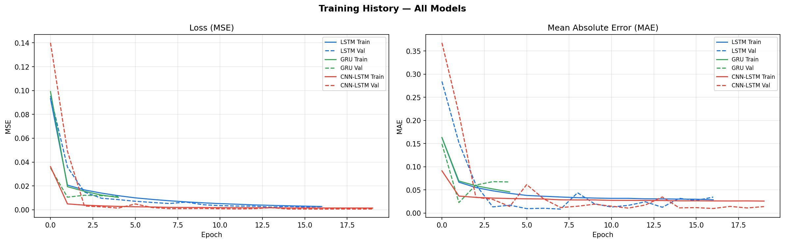
Figure 5: Training history for all three architectures — MSE loss (left) and MAE (right) across epochs, with solid lines for training and dashed lines for validation.

5.2 Test Set Performance
Table 1 summarises the four error metrics computed on the held-out test set, with all values expressed in the original price scale following inverse MinMax transformation.

Table 1: Test set error metrics for all three architectures (original price scale).
Model | RMSE | MAE | MAPE (%) | R²
LSTM | 0.00356 | 0.00301 | 0.2552 | 0.9182
GRU | 0.00431 | 0.00341 | 0.2897 | 0.8802
CNN-LSTM | 0.00376 | 0.00277 | 0.2344 | 0.9088

LSTM achieved the lowest RMSE (0.00356) and the highest R² (0.9182), confirming it as the best overall performer by the primary metric. CNN-LSTM ranked second with an RMSE of 0.00376 and R² of 0.9088 — notably it achieved the lowest MAE (0.00277) and MAPE (0.2344%), suggesting its predictions were closer on average even if the squared-error penalty occasionally penalised it. GRU produced the weakest results across all four metrics, with RMSE of 0.00431 and R² of 0.8802, though the difference remains small in absolute price terms given that EUR/USD trades near 1.17.
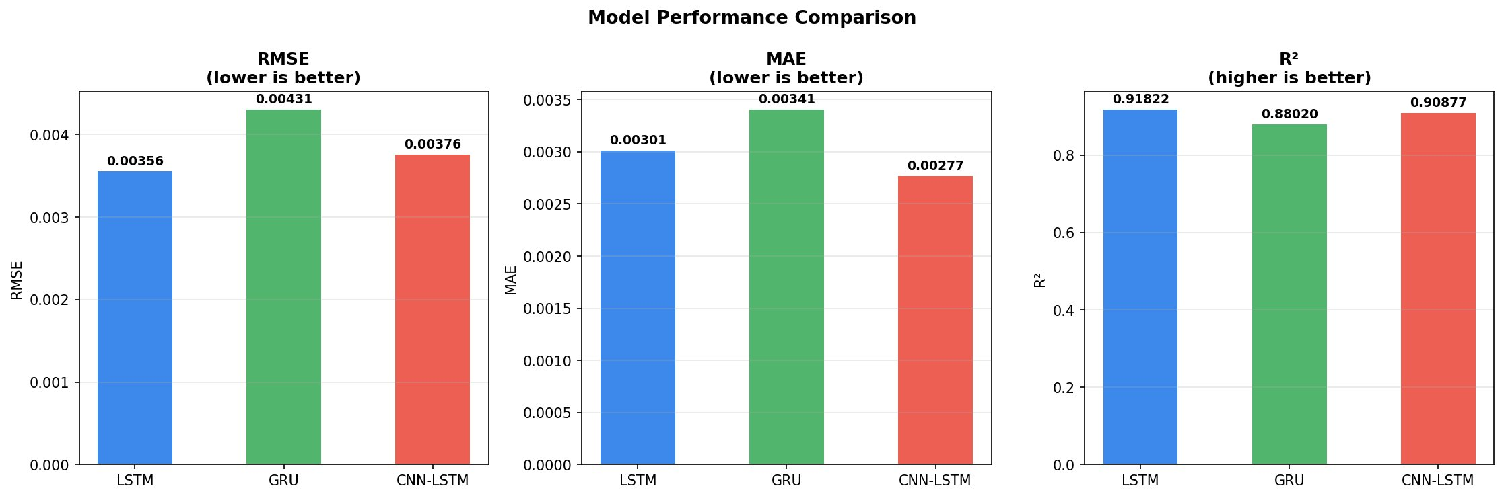
Figure 6: Bar chart comparison of RMSE, MAE, and R² across the three architectures on the test set.

5.3 Prediction Quality
Figure 7 shows predicted versus actual EUR/USD closing prices over the last 300 test bars for each model. All three architectures track the general directional trend competently — capturing the downward drift from 1.182 to approximately 1.169 across the window. LSTM and CNN-LSTM maintain tighter alignment with the actual series, while the GRU predictions display a slightly smoother trajectory that lags at sharp reversal points. The shaded residual bands confirm that CNN-LSTM accumulates the least unsigned error over the sequence.
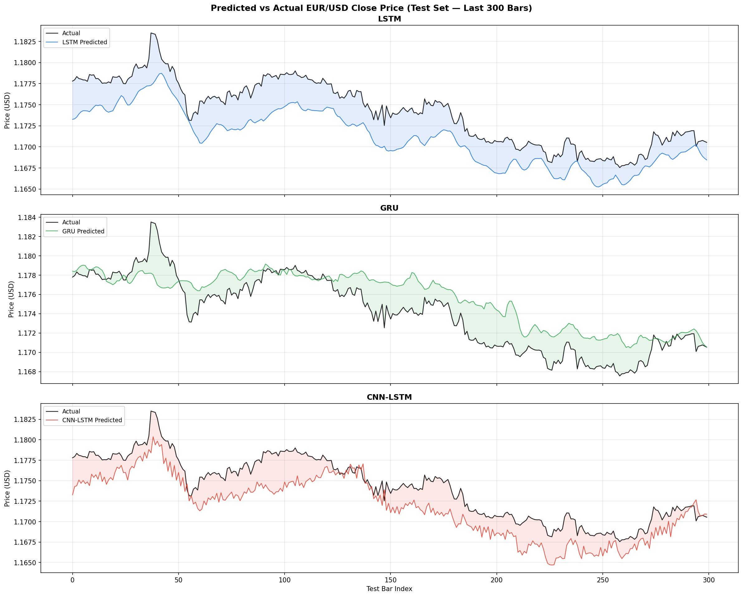
Figure 7: Predicted vs actual EUR/USD closing price over the last 300 test bars for LSTM (top), GRU (middle), and CNN-LSTM (bottom).
The scatter plots in Figure 8 map predicted prices against actual prices for the full test set. A perfect model would place all points on the diagonal dashed line. LSTM's cluster is the tightest and most linear (R² = 0.9182), GRU shows the most spread, particularly at higher price levels, and CNN-LSTM sits between the two with slight heteroscedasticity at the upper end of the price range — consistent with greater difficulty forecasting the upward momentum phase.
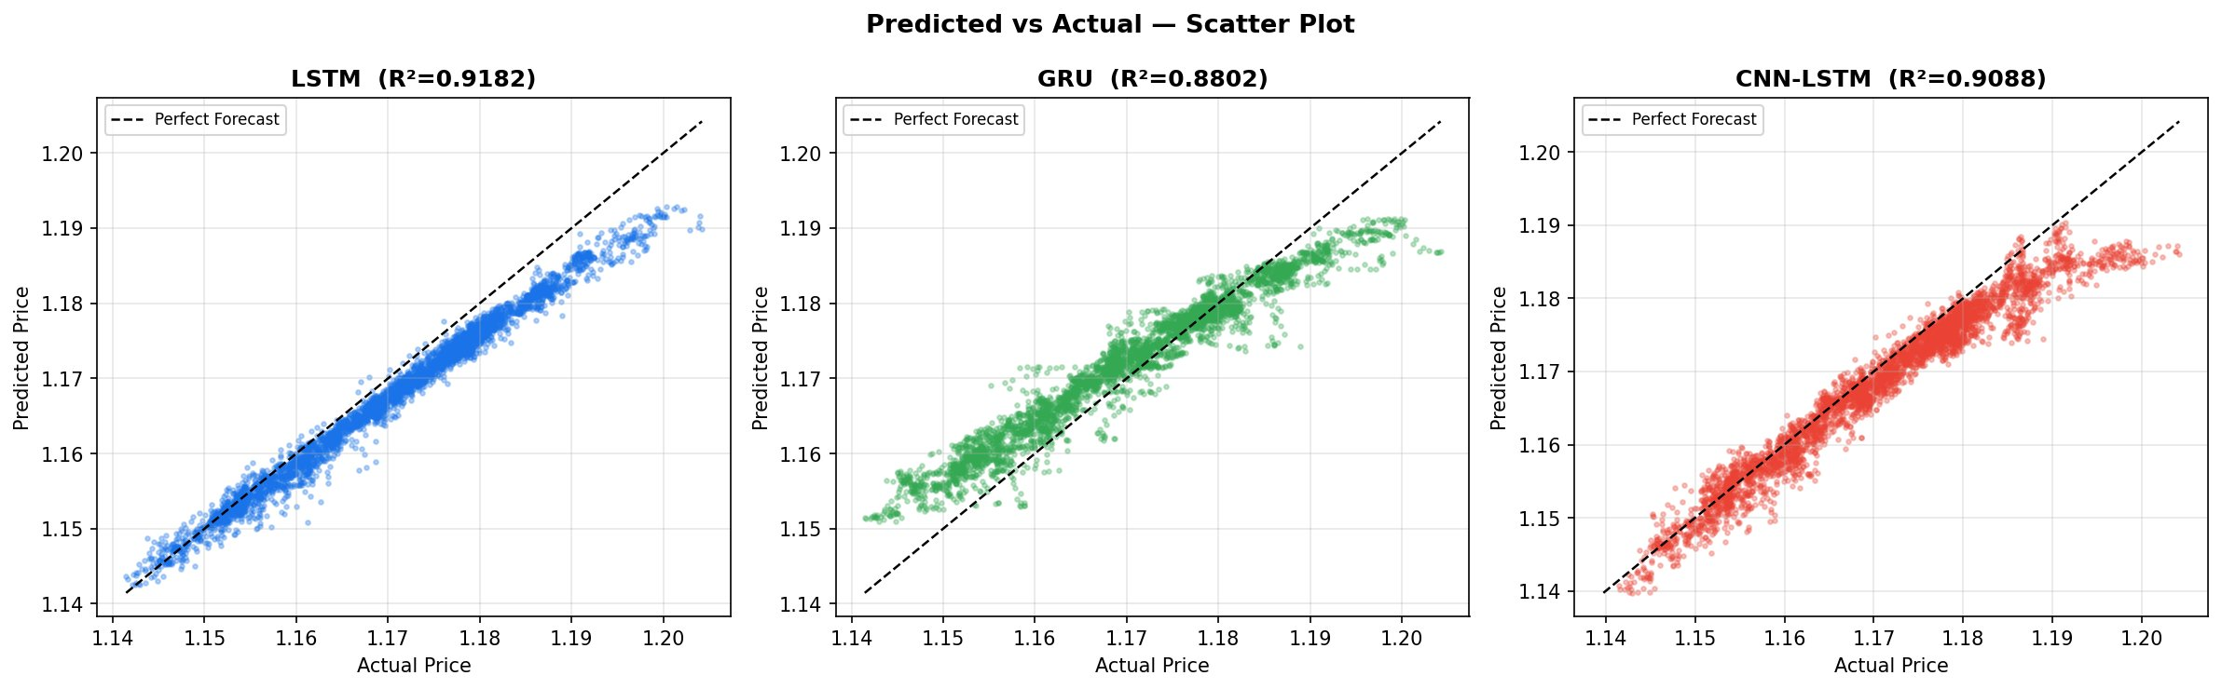
Figure 8: Predicted vs actual scatter plots for LSTM (R²=0.9182), GRU (R²=0.8802), and CNN-LSTM (R²=0.9088) on the full test set.

5.4 Residual Analysis
Figure 9 presents residual diagnostics — scatter plots of residuals against fitted values (top row) and residual frequency distributions (bottom row). All three models show residuals broadly centred around zero, which is reassuring. However, the LSTM residual scatter exhibits a slight positive skew at lower fitted values, indicating a tendency to under-predict prices in the lower range of the test period — likely a consequence of the rapid price appreciation that characterised the early test segment. GRU residuals are more symmetrically distributed but with heavier tails. CNN-LSTM residuals are the most tightly concentrated around zero, which aligns with its superior MAE score.
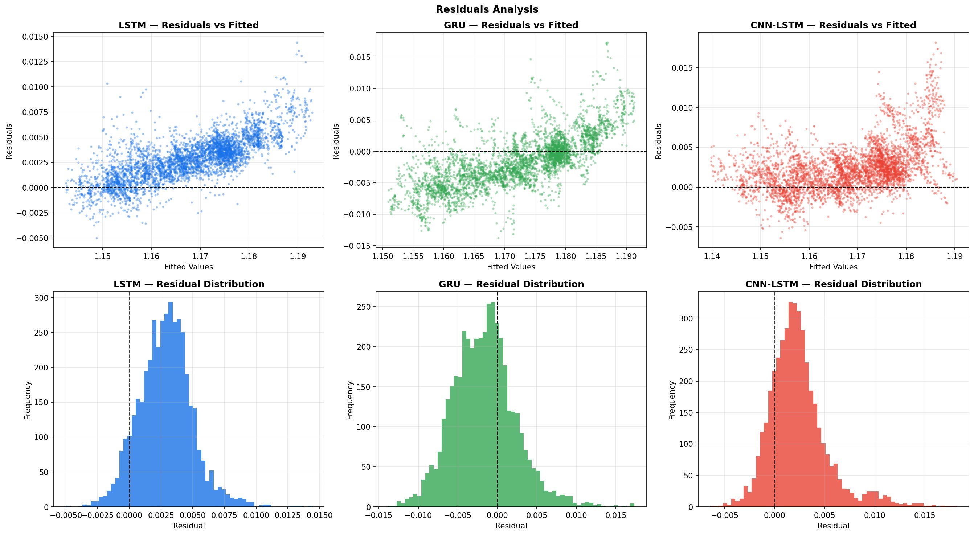
Figure 9: Residuals analysis — scatter of residuals vs fitted values (top) and residual distribution histograms (bottom) for LSTM, GRU, and CNN-LSTM.

6. Discussion
The results broadly support the hypothesis that LSTM-based architectures are competitive for short-horizon forex forecasting. The LSTM's advantage in RMSE and R² likely reflects its ability to retain regime-relevant context over the full 48-step look-back window — the gating mechanism allows it to selectively preserve information about the prevailing trend even when short-term noise would otherwise obscure it.
CNN-LSTM's superior MAE and MAPE, despite a slightly weaker RMSE, is an important nuance. In a trading context, MAPE (0.2344%) translates to a mean absolute error of roughly 2.7 pips on a 1.17 quote. This is arguably the most practically relevant metric: the average individual prediction error is smaller for CNN-LSTM, even if it produces occasional larger outliers that inflate RMSE. The convolutional front-end appears to act as a useful noise filter, suppressing high-frequency micro-fluctuations before passing smoother representations to the LSTM layers.
GRU's underperformance is somewhat surprising given that it typically matches LSTM on many sequence tasks. One plausible explanation is the length of the input sequence: at 48 steps (24 hours), the added memory capacity of LSTM's separate cell state becomes genuinely valuable. GRU's single hidden state may compress long-range dependencies less effectively at this horizon.
A limitation common to all three models is the persistent small positive bias evident in the residual plots. This is a known property of regression-based forecasters on trending series: the model learns the mean behaviour of the training distribution but struggles to lead at inflection points. Future work could address this through direction-aware loss functions or ensemble methods that explicitly model regime transitions.

7. Conclusion
This study compared three deep learning architectures for next-bar EUR/USD M30 close price forecasting across a 27-month dataset incorporating 31 engineered features. The LSTM achieved the best overall accuracy (RMSE = 0.00356, R² = 0.918), followed closely by CNN-LSTM (RMSE = 0.00376, R² = 0.909), with GRU performing weakest (RMSE = 0.00431, R² = 0.880). Notably, CNN-LSTM produced the lowest mean absolute and percentage errors, suggesting it may be preferable in contexts where consistent per-prediction accuracy matters more than outlier control.
All three models demonstrated strong convergence behaviour under the early stopping and adaptive learning rate strategy, typically stabilising within 20 epochs and showing no meaningful overfitting. The feature set combining classical technical indicators with candlestick patterns and temporal markers provided sufficient signal for R² values above 0.88 across all architectures — a meaningful result given the well-documented difficulty of short-term forex prediction.

References
Dukascopy Bank SA (2024). Historical FOREX Data — EUR/USD M30 Bid OHLCV. Retrieved from https://www.dukascopy.com
Hochreiter, S. and Schmidhuber, J. (1997). Long Short-Term Memory. Neural Computation, 9(8), 1735–1780.
Cho, K., van Merrienboer, B., Gulcehre, C., Bahdanau, D., Bougares, F., Schwenk, H. and Bengio, Y. (2014). Learning Phrase Representations using RNN Encoder-Decoder for Statistical Machine Translation. arXiv:1406.1078.
Livieris, I.E., Pintelas, E. and Pintelas, P. (2020). A CNN-LSTM model for gold price time-series forecasting. Neural Computing and Applications, 32, 17351–17360.
Sezer, O.B., Gudelek, M.U. and Ozbayoglu, A.M. (2020). Financial time series forecasting with deep learning: A systematic literature review. Applied Soft Computing, 90, 106181.

